Blood Bank Management System

*A*

*Mini Project Report*

*Submitted in partial fulfilment of the*

*Requirements for the award of the Degree of*

**BACHELOR OF ENGINEERING**

IN

**INFORMATION TECHNOLOGY**

By

<Joshua Peter ><1602-19-737-075>

<Shoaib Ali Kamthan><1602-19-737-104>



**Department of Information Technology**

**Vasavi College of Engineering (Autonomous)**

**(Affiliated to Osmania University)**

**Ibrahimbagh, Hyderabad-31**

**2020**

**Vasavi College of Engineering (Autonomous)**

**(Affiliated to Osmania University)**

**Hyderabad-500 031**

**Department of Information Technology**



**DECLARATION BY THE CANDIDATE**

We, **Joshua Peter** and **Shoaib Ali Kamthan** bearing hall ticket numbers,1602-19-737-075 and 1602-19-737-104 respectively, hereby declare that the project report entitled **“BLOOD BANK MANAGEMENT SYSTEM**” is submitted in partial fulfilment of the requirement for the award of the degree of **Bachelor of Engineering** in **Information Technology**.

This is a record of bonafide work carried out by us and the results embodied in this project report have not been submitted to any other university or institute for the award of any other degree or diploma.

Joshua Peter

1602-19-737-075

Shoaid Ali Kamthan

1602-19-737-104

(Faculty In-Charge) (Head, Dept. of IT)

**ACKNOWLEDGEMENTS**

I would like to take this opportunity and thank everyone who have helped me in completing this project.

First of all, I would like to express my special thanks of gratitude to our faculty in-charge to Ms. D R L Prasanna, Assistant Professor, Department of Information Technology, Vasavi College of Engineering for the esteemed guidance, moral support and invaluable advice provided by them for the success of the mini project and also gave me the golden opportunity to do this project “BLOOD BANK MANAGEMENT SYSTEM”.

This helped me in knowing about the various concepts of C Programming Language, which I haven’t known before. It helped me in deliberating thoughts about the concept and to enhance my skills too.

Secondly, I would also like to thank few websites and youtube channels which I visited when I was doing my project. They have really taught me know the amazing program skills where you can make your project more flexible with many possible use cases.

**Sincerely,**

**Joshua Peter**

**1602-19-737-075**

**Shoaid Ali Kamthan**

**1602-19-737-104**

**ABSTRACT**

Our mini project is “BLOOD BANK MANAGEMENT SYSTEM”. It is something which is very useful during emergency. In today’s world, people often come across situations where they need blood or blood plasma. In such emergency conditions blood donor or plasma donor details becomes really handy.

So, in our project we provide facilities for the user to search for the blood donor using the blood group, donor’s ID and the city in which they require blood. And the details of the donor are displayed to the user. Even the new donors who want to donate their blood can register. The amount will also be calculated and is displayed to the user which has to be paid to the donor. The software can further be improved using frameworks, UPIs and database. This software will be implemented using all the primitive types of data types in c.

**TABLE OF CONTENTS**

1. Introduction……………………………………………6
2. Technology…………………………………………….8
3. Proposed Work………………………………………...9
4. Results…………………………………………………24
5. Additional Knowledge Acquired………………………29
6. Conclusion and Future Work…………………………..30
7. References……………………………………………...31

**1. INTRODUCTION**

**1.a. ABOUT THE PROJECT**

“BLOOD BANK MANAGEMENT SYSTEM” is a console-based C Project which acts as an application to search for the details of the blood donor or plasma donor. The intent behind this project is to provide the information of the donor to the people, who are in need of blood which will be very useful in the time of emergency.

**PROJECT DOMAIN**

The domain of the project is the targeted subject area of a computer program. It is a term most commonly used in software engineering. Formally, it represents the target subject of a specific programming project, whether narrowly or broadly defined. To be concise, a domain in the realm of software engineering commonly refers to the subject area on which the application is intended to apply. Within a domain, there are two categories:

1. Technical Domain

2. Functional Domain

**TECHNICAL DOMAIN**

This project falls under the domain of a Console Application. A console application is a program designed to be used via a text-only computer interface, such as a text terminal, the command line interface of some operating systems or the text-based interface.

**FUNCTIONAL DOMAIN**

“BLOOD BANK MANAGEMENT SYSTEM” comes under the Health care domain, because we are aiming to help users to get the details of the blood donor or plasma donor.

**1.b. FEATURES**

Our vision for this project is to provide the details of the donor to the people, who are in need of blood. It also allows us to register as a new donor. It allows the user to find the details of the donor either on blood group basis, city basis or on the basis of donor’s ID. It also displays the amount to be paid to the donor. This information would be really handy in the time of emergency as user would be comfortable in getting the details of the donor on their phone rather than asking for help in the hospitals or their family members.

**Register**

This will help the new donor to register to donate blood or plasma. The information given by the donor will be really helpful for the user who are in emergency.

**Find Blood Donor**

There are 3 ways for the user to get the blood donor.

Firstly, the user can find blood donor using blood group. It allows the user to find the details of the donor when they are in need of a particular type of blood group.

Secondly, the user can find the donor using donor’s ID. It allows the user to get the details of a particular donor who is familiar to him. As the donor is already known he would be comfortable in asking for blood donations.

Lastly, the user can find the donor using city. This would be useful when the hospital asks for the exchange method. Which is basically donating different type of blood to the hospital, which in return provide the blood that is required for the patient.

**Find Plasma Donor**

It helps the user to find the plasma donor. It allows the user to get the details of a plasma donor which is very useful in this pandemic situation. The information of the plasma donor would be really handy.

**Calculate Amount**

It would display the amount that should be paid to the donor. As it would be useful to know about the amount to be paid and to be ready with the amount at the time of blood donations.

**2. TECHNOLOGY**

All computer software needs certain hardware components or other software resources to be present, in order for computers to be used efficiently. These prerequisites are known as System Requirements. Within this, we have two types – Software Requirements and Hardware Requirements.

**2.a. SOFTWARE REQUIREMENTS**

Software Requirements deal with defining the software resource requirements and prerequisites that need to be installed on a computer to provide optimal functioning of an application. These preconditions are generally not included in the software installation package and need to be installed separately. In order to use “BLOOD BANK MANAGEMENT SYSTEM”, one should have the following:

• Operating System: Windows 7 and above

• C Compiler: GNU Compiler Collection (GCC)

• Editor: Any text editor (preferably Visual Studio Code)

**2.b. HARDWARE REQUIREMENTS**

Hardware requirements refer to the common set requirements defined by any operating system or software application and are usually the physical computer resources. In this, we look into the architecture, processing power, memory, secondary memory, display adapter and peripherals.

In order to use “BLOOD BANK MANAGEMENT SYSTEM”, one should have the following:

• Processor: Ryzen 5 / Intel i5 and above

• Memory: 8 GB RAM

**3. PROPOSED WORK**

**3.a. DESIGN**

Our approach in designing “BLOOD BANK MANAGEMENT SYSTEM” was to divide our users into two groups – the users and the system. The user is a day-to-day consumer whose only goal is to get details of the donor. The system’s goal is to maintain, store, update and retrieve the details of the donor. It also searches for the details when user asks for information.

**3.a.1. The Use case diagram: -**

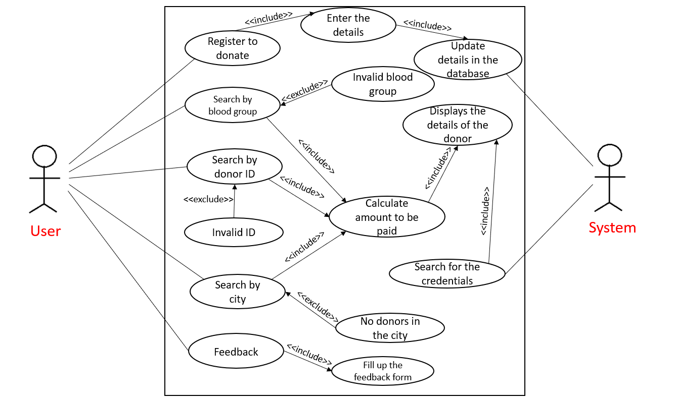

**3.a.2 Flowchart: -**

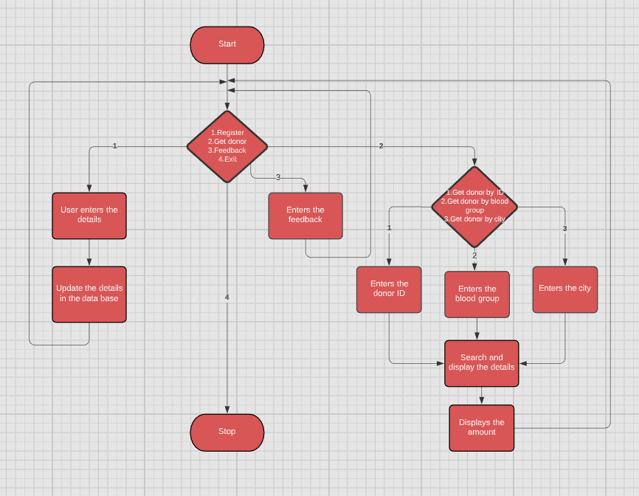

**3.b.1. Description: -**

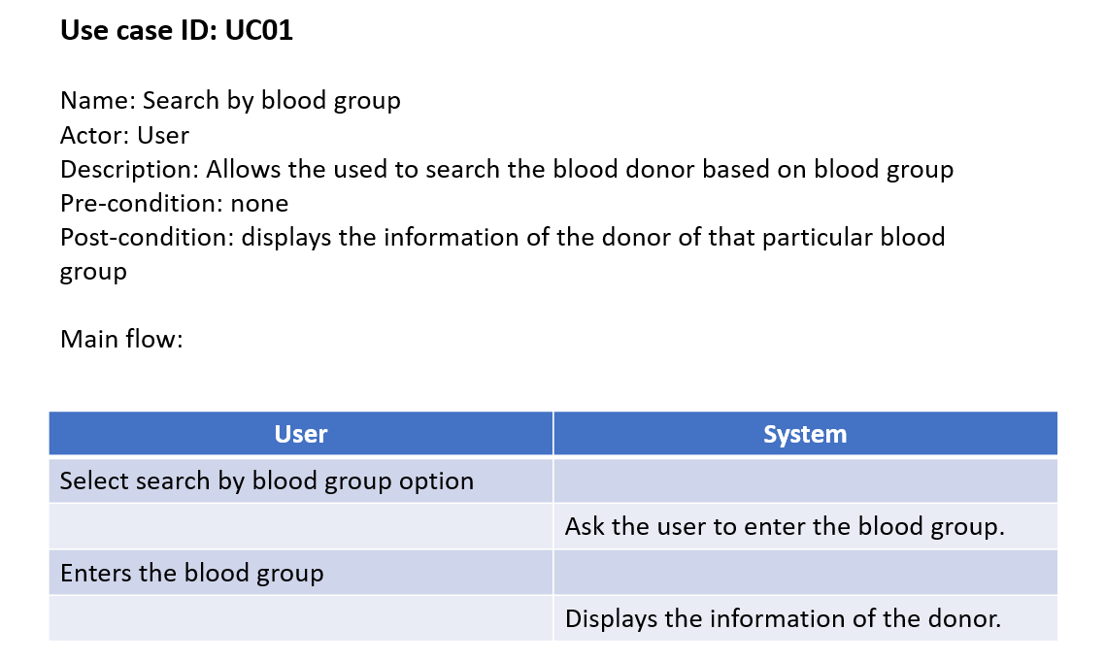

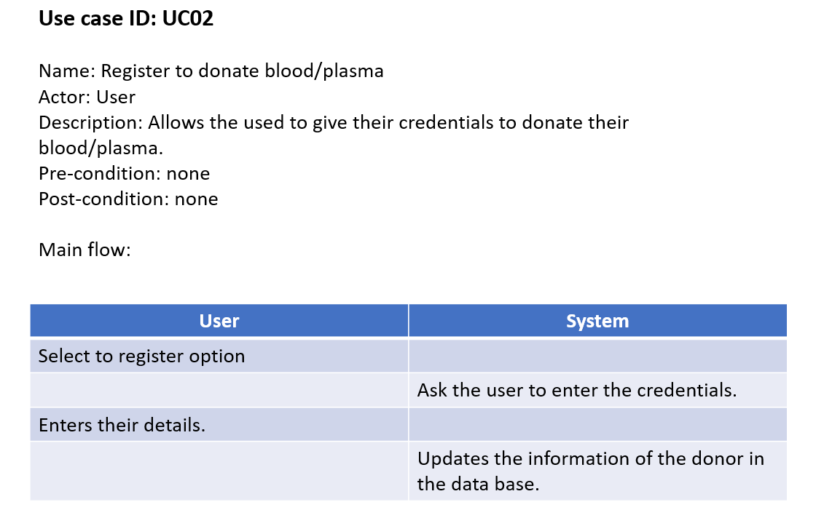

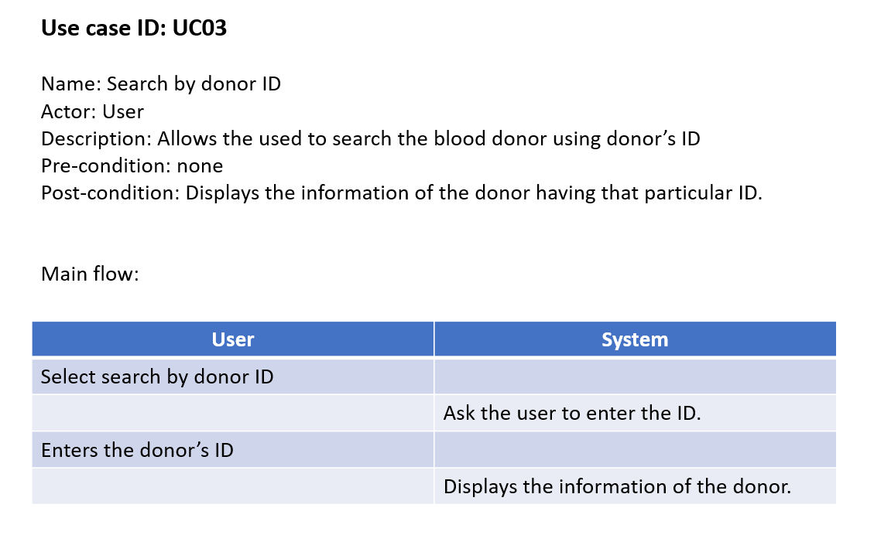

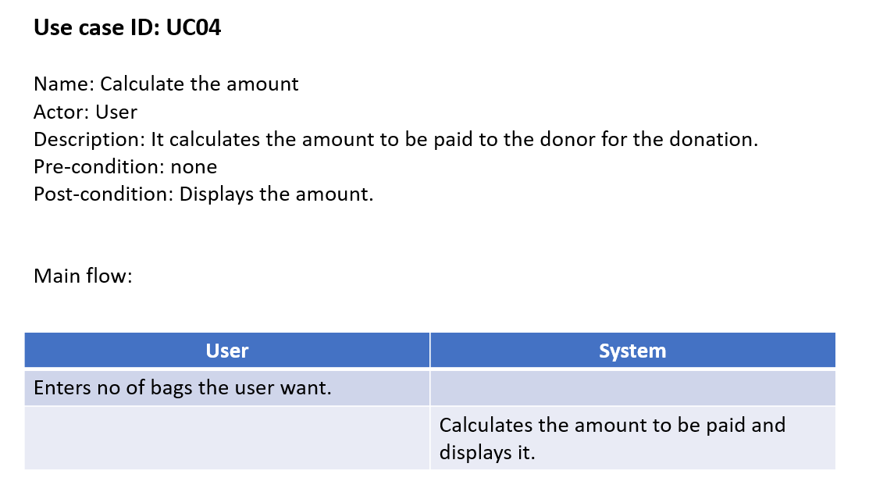

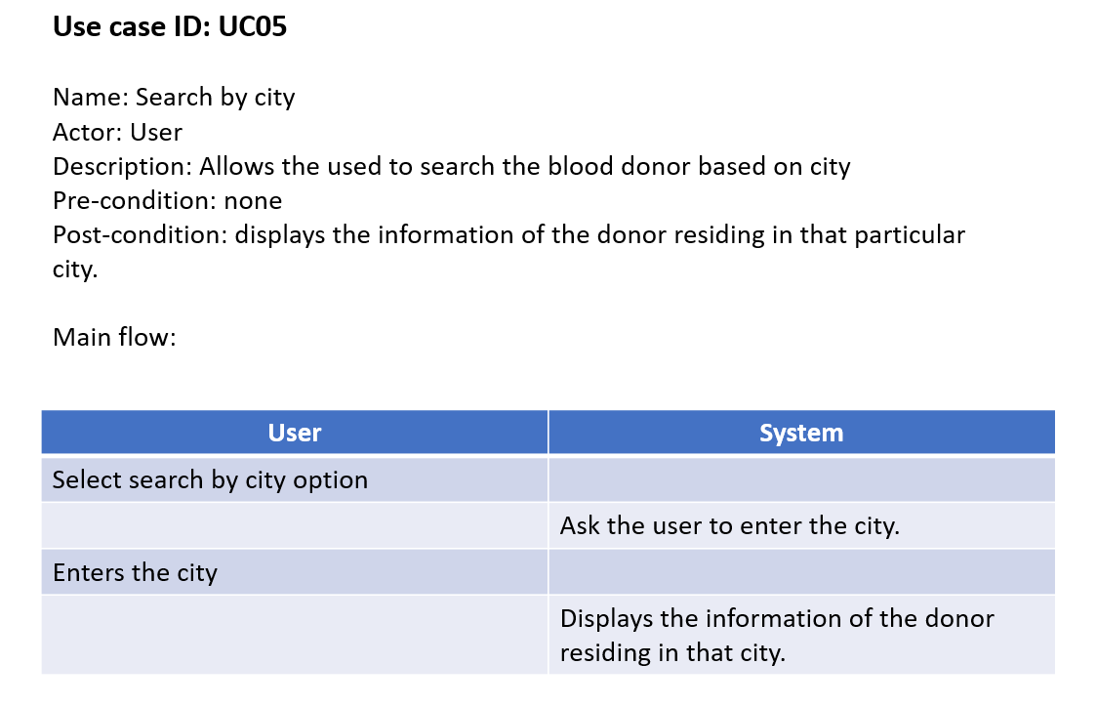

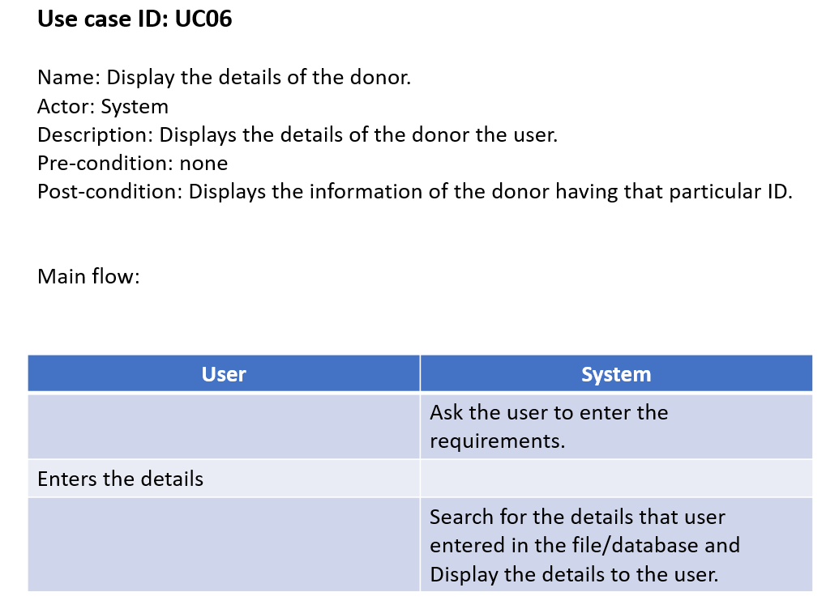

**3.b.2. Algorithm of a module:-**

**//diplay details of the donor.**

void details_donor()

{

system("color 8e");

SetColor(0);

int id;

char a='y';

fp=fopen("blood_database.txt","r");

if(fp==NULL)

{

printf("Cannot Open File");

exit(1);

}

fflush(stdin);

printf("\n\n\n\n\n\n\n\n\n");

printf("\n\t\t\t\t\tEnter the Donor Id : -");

scanf("%d",&id);

int max_id = max_Donor_id();

while(id <= 1000 || id >=max_id)

{

printf("\n\n\t\t\t\t\tSORRY INVALID INPUT\n");

printf("\n\t\t\t\t\tEnter correct Donor Id :-");

scanf("%d",&id);

}

rewind(fp);

while(fread(&b,sizeof(struct Blood_Donor),1,fp)==1)

{

if(b.ID==id) //checking for the mathching donor's ID in the Database.

{

printf("\n\t\t\t\t\tDETAILS OF THE DONOR WITH ID '%d'",b.ID);

printf("\n\t\t\t\t\tName: %s",b.Name);

printf("\n\t\t\t\t\tDonor Id: %d",b.ID);

printf("\n\t\t\t\t\tAge: %d",b.Age);

printf("\n\t\t\t\t\tAddress of the donor: %s",b.Address);

printf("\n\t\t\t\t\tCity: %s ",b.City);

printf("\n\t\t\t\t\tPhone No:- %s",b.Phone_No);

printf("\n\t\t\t\t\tEmail: %s",b.Email);

printf("\n\t\t\t\t\tBlood Group: %s\n",b.Blood_Group);

fclose(fp);

}

}

int x;

printf("\n\n\t\t\t\t\tEnter [1] to go back to menu :-");

fflush(stdin);

scanf("%d",&x);

while(x != 1)

{

printf("\n\n\t\t\t\t\tEnter [1] to go back to menu :-");

fflush(stdin);

scanf("%d",&x);

}

if(x == 1)

{

system("cls");

return;

}

}

### 3.b.3 GITHUB/FOLDER STRUCTURE

### 

We have uploaded all the files required to run the program. The source code and all the text files needed to run the code are present in the repository. The README file contains the information about the project.

<https://github.com/joshua-peter>

<https://github.com/shoaibalikamthan>

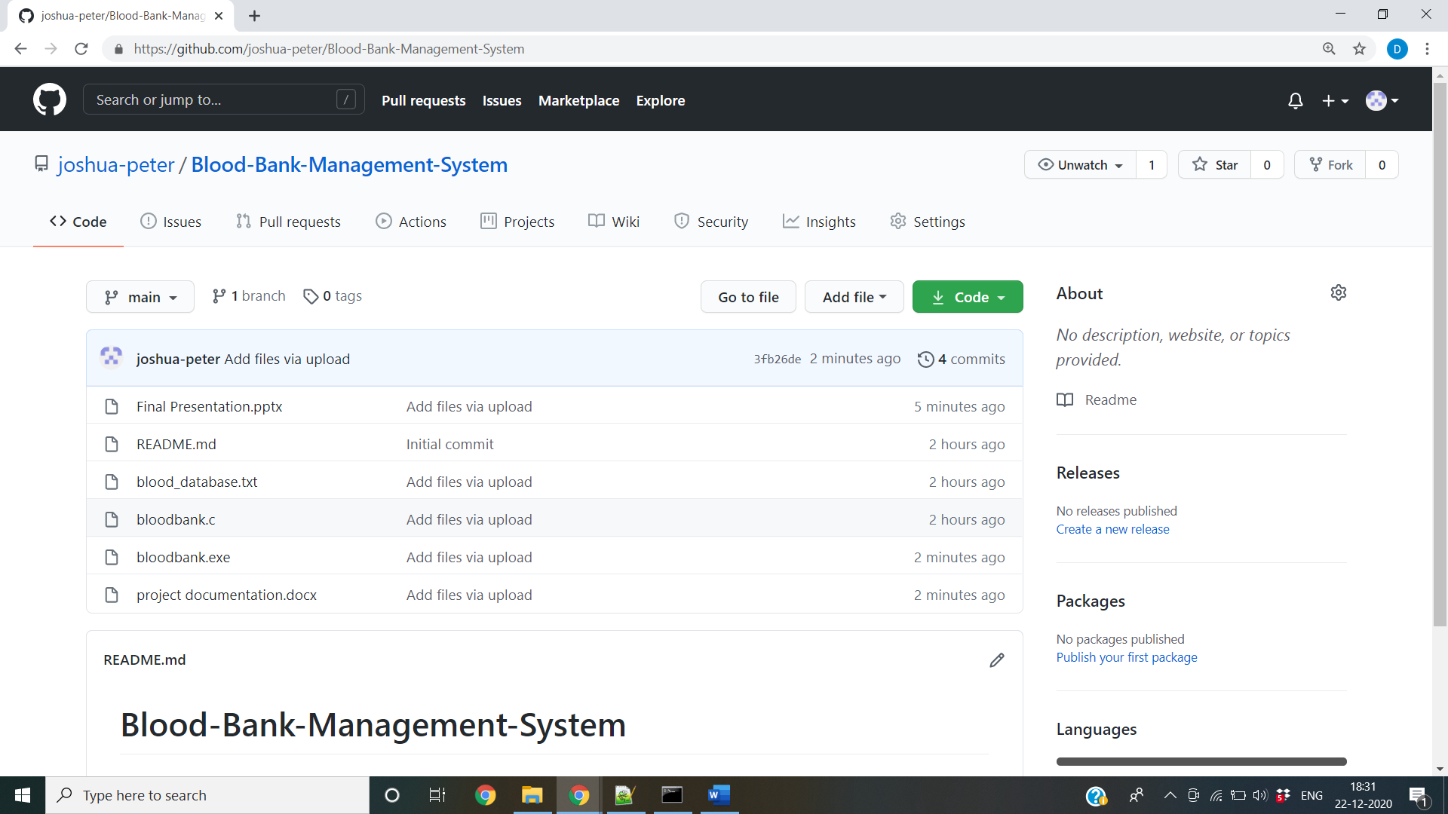

## **3.c. TESTING**

Testing is a method to check whether the actual product matches the expected requirements and to ensure that the product is defect-free. This process involves execution of various parts of the product either using manual or automated tools. The purpose is to identify errors, gaps or missing requirements in contrast to the actual requirements.

### TEST PLAN

We approached testing our console application by analysing each module separately. First, we coded the requirements and then manually tested each feature present in the module to cover any gaps that might occur.

### USER TEST CASES

The user has 6 major functionalities:

Below are the testcases which we have compiled together manually.

|  |  |  |  |
| --- | --- | --- | --- |
| **Test Case Template** | |  |  |
| **Test Case ID:** TC01 | | **User Case ID:**  UC01 |  |
| **Test Case Title:** User - Search by Blood Group | |
| **Test Case Description: -** The user selects search donor using blood group | |
| **Test Steps:** | **Expected Result:** | **Actual Result:** |  |
| 1. System displays to enter blood group  2. User enters the blood group | The system will check and prompts “Enter valid blood group” if it is invalid. | Displays “Enter a valid blood group” if it is invalid. |  |

|  |  |  |
| --- | --- | --- |
| **Test Case Template** | |  |
| **Test Case ID:** TC02 | | **User Case ID:**  UC02 |
| **Test Case Title:** User – phone number | |
| **Test Case Description:** The user selects registration option and give less or more digits while entering phone number. | |
| **Test Steps:** | **Expected Result:** | **Actual Result:** |
| 1. System displays prompt phone number. 2. The user enters the phone number | The system will check and prompts “Enter valid phone number” if it is invalid. | Displays “Enter a valid phone number” if it is invalid. |

|  |  |  |  |
| --- | --- | --- | --- |
|  | | **Test Case Template** |  |
| **Test Case ID:** TC03 | |  | **User Case ID:** |
| **Test Case Title:** User – Blood Group | | | UC02 |
| **Test Case Description:** The user selects registration option and enters blood group | | |
| **Test Steps:** | **Expected Result:** | | **Actual Result:** |
| 1. System displays to enter blood group. 2. The user enters the blood group. | The system will check and prompts “Enter valid blood group” if it is invalid. | | Displays “Enter a valid blood group” if it is invalid. |

#### 

|  |  |  |
| --- | --- | --- |
| **Test Case Template** | |  |
| **Test Case ID:** TC04 | | **User Case ID:**  UC03 |
| **Test Case Title:** User – register - age | |
| **Test Case Description:** The user selects registration option and enters the age. Below 18 and above 65 years are not eligible. | |
| **Test Steps:** | **Expected Result:** | **Actual Result:** |
| 1. System displays to enter age. 2. The user enters the age. | The system will check and prompts “You are not eligible for donating blood” if he is not eligible for donating. | Displays “You are not eligible for donating blood” if he is not eligible for donating. |

|  |  |  |
| --- | --- | --- |
| **Test Case Template** | | |
| **Test Case ID:** TC05 | | **User Case ID:**  UC04 |
| **Test Case Title:** User - Search by ID | |
| **Test Case Description:** The user selects to search donor using donor’s ID. | |
| **Test Steps:** | **Expected Result:** | **Actual Result:** |
| 1. System displays to enter donor ID.  2. User enters the donor ID. | The system will check and prompts “Enter valid ID” if it is invalid. | Displays “Enter a valid ID” if it is invalid. |

|  |  |  |
| --- | --- | --- |
| **Test Case Template** | | |
| **Test Case ID:** TC06 | | **User Case ID:**  UC05 |
| **Test Case Title:** User - Search by city | |
| **Test Case Description:** The user selects to search donor using city. | |
| **Test Steps:** | **Expected Result:** | **Actual Result:** |
| 1. System displays to enter city.  2. User enters the city. | The system will check and prompts “Enter valid city” if it is invalid. | Displays “Enter a valid city” if it is invalid. |

|  |  |  |
| --- | --- | --- |
| **Test Case Template** | |  |
| **Test Case ID:** TC07 | | **User Case ID:**  UC06 |
| **Test Case Title:** Display donor’s details | |
| **Test Case Description:** The user selects to show details of the donor. | |
| **Test Steps:** | **Expected Result:** | **Actual Result:** |
| 1. System displays to enter donor ID.  2. User enters the donor ID. | The system will check and prompts “Enter valid ID” if it is invalid. | Displays “Enter a valid ID” if it is invalid. |

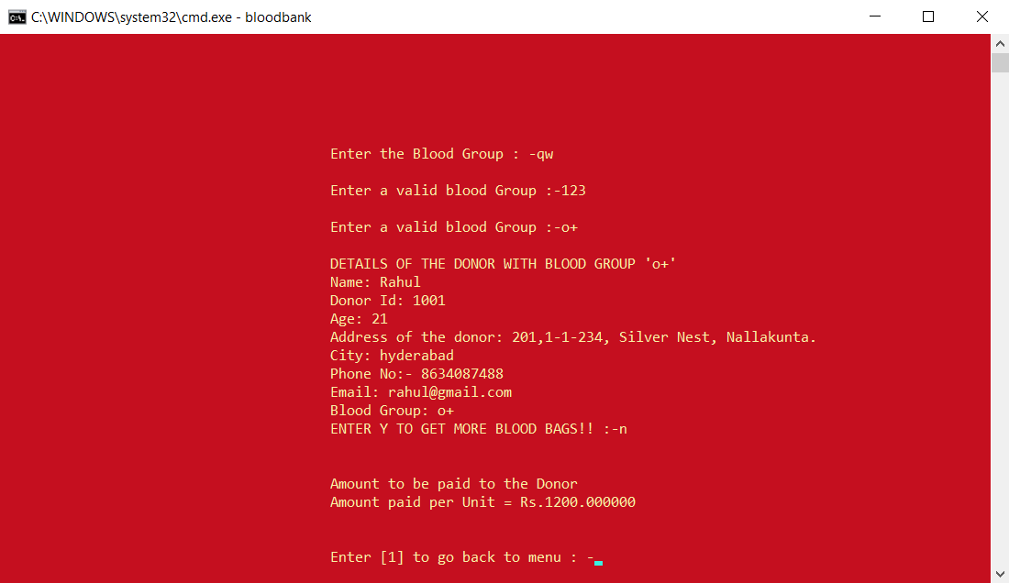

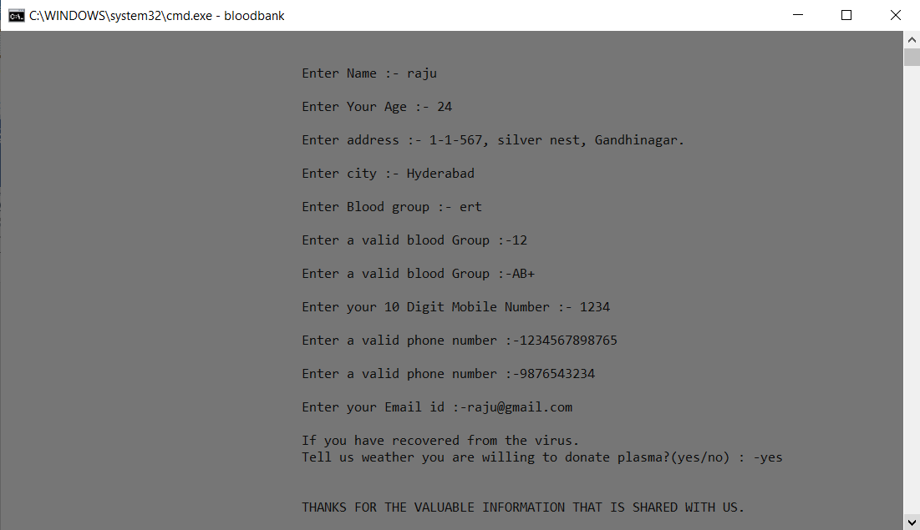

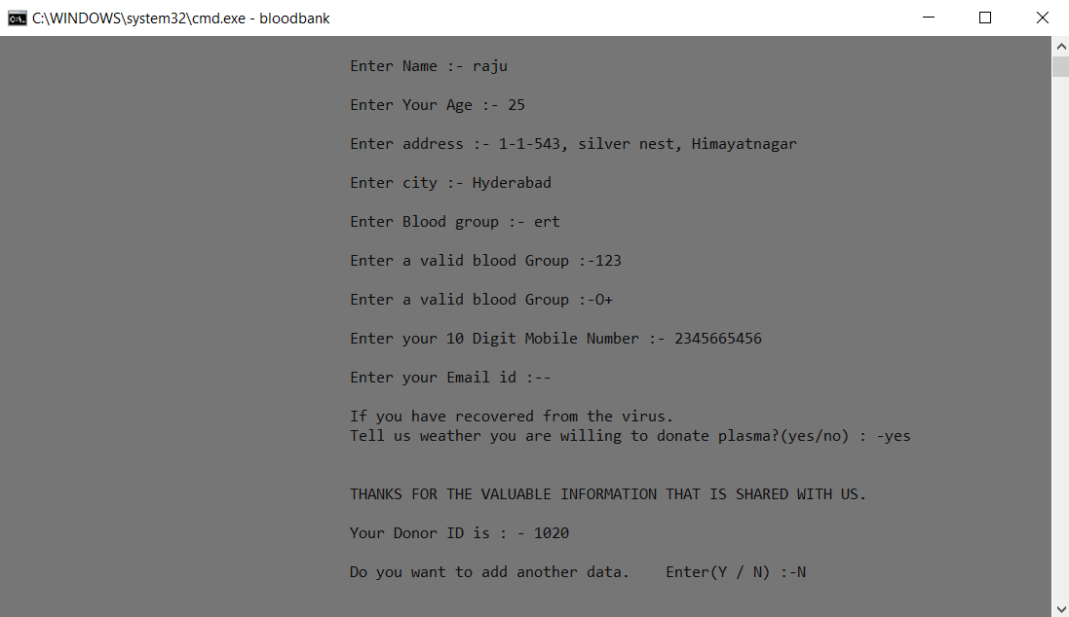

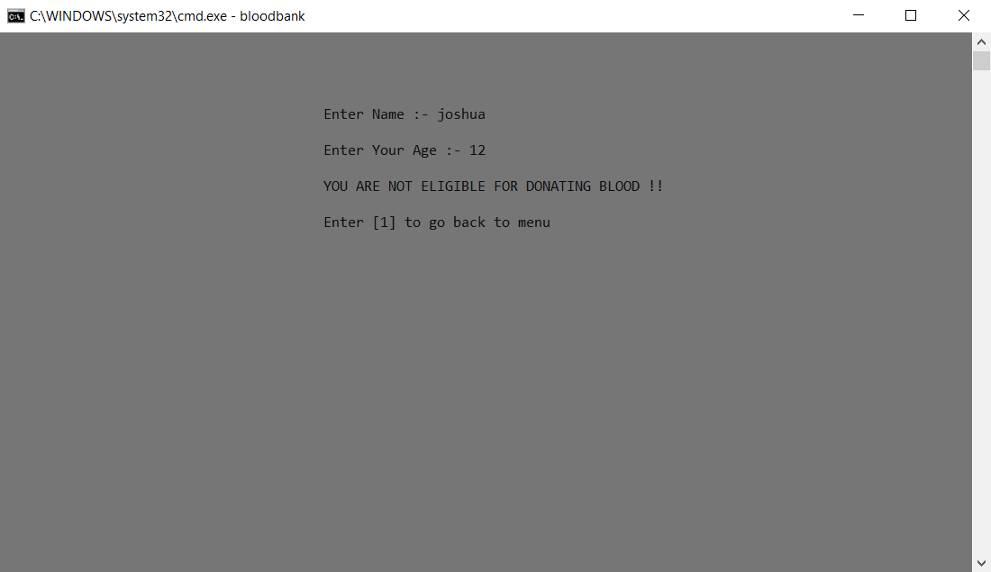

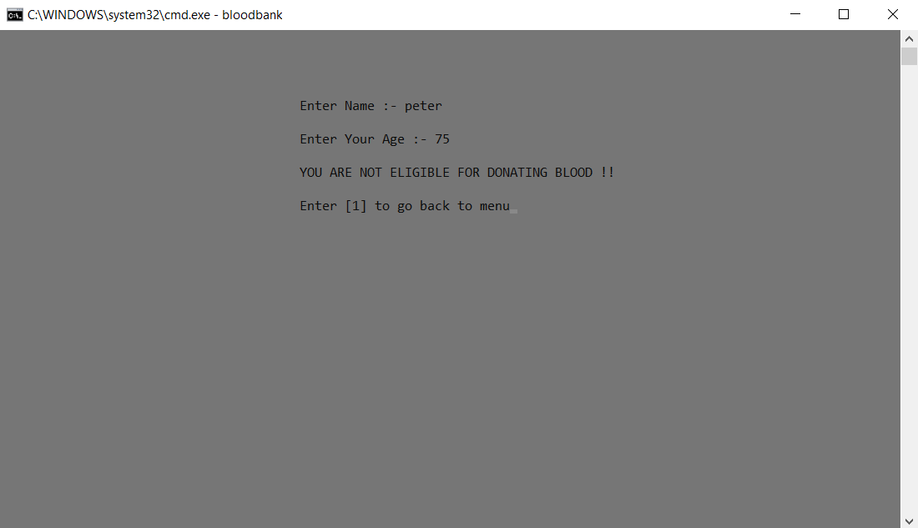

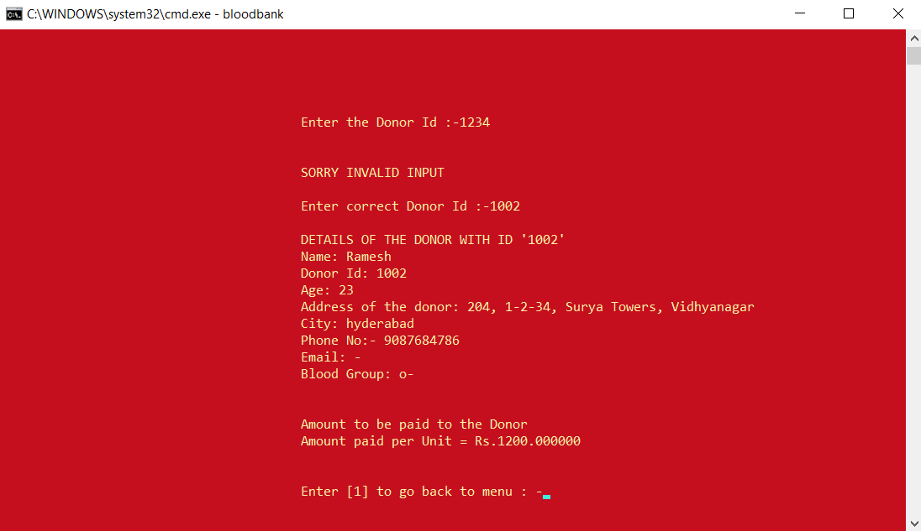

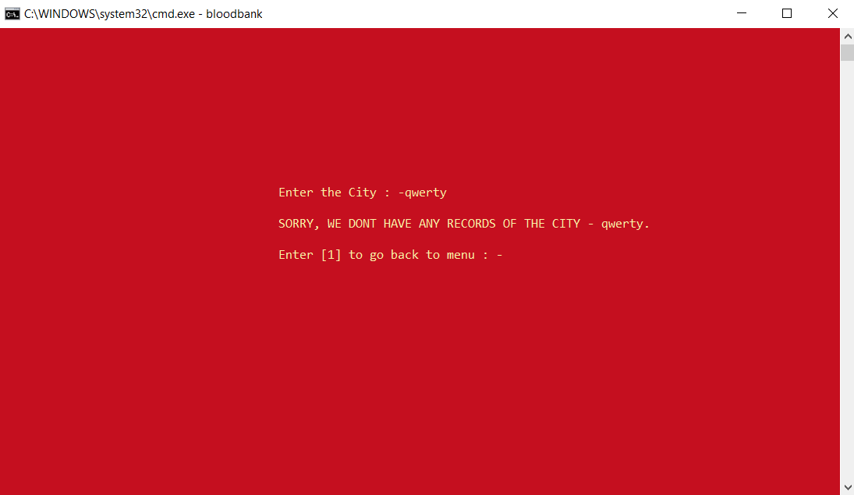

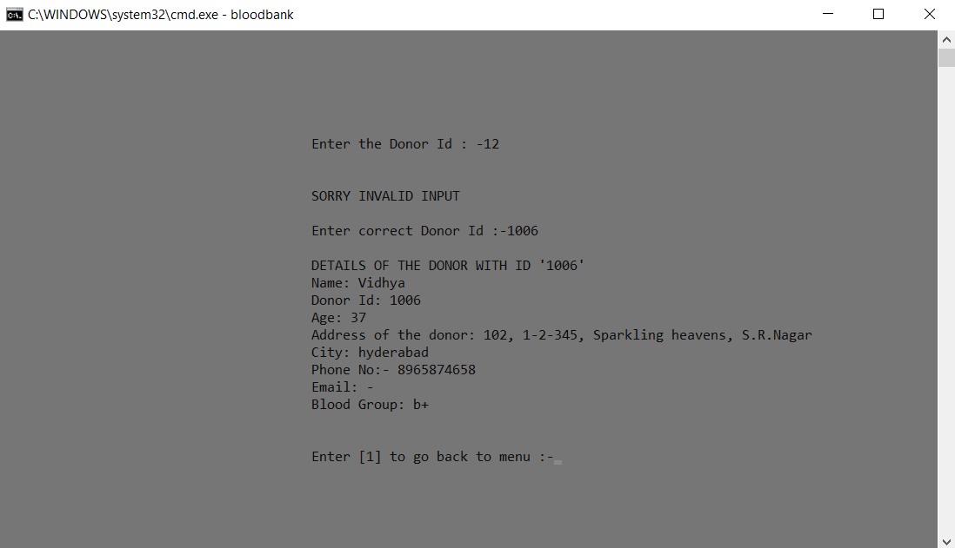

# **4.** **RESULTS**

We have successfully developed a platform for users of all age groups to utilize. Below are the output screenshots of the testcases mentioned. Our project “BLOOD BANK MANAGEMENT SYSTEM” is a unique idea, it may be similar to the blood banks but it is far away different too. Our basic intent was to digitalize the information. So that it would easy for the user to get the details of the donor on their phone rather than standing in long queues in the blood banks, asking the hospital staff or their family members. As it gives the information of the amount to be paid to the donor beforehand it would be easy for the user to be ready with the amount after donation of the blood which is different from other systems.

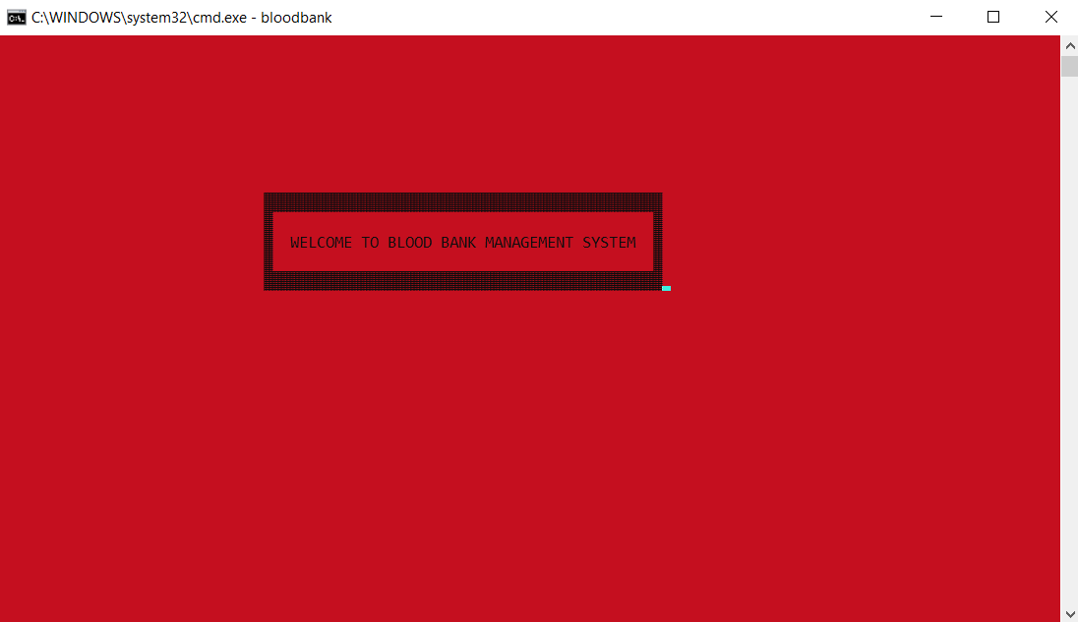

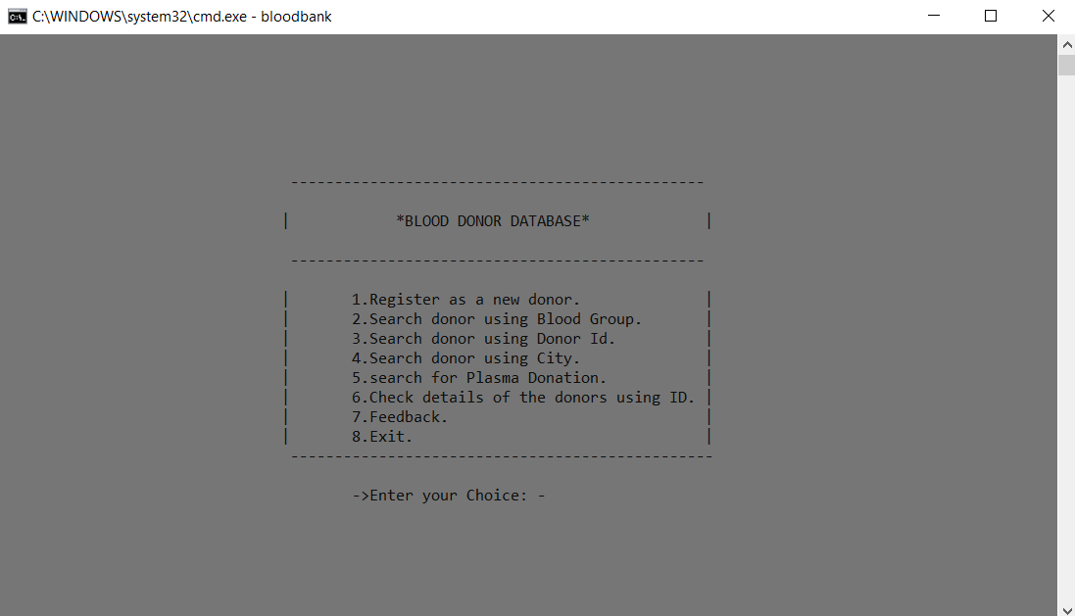

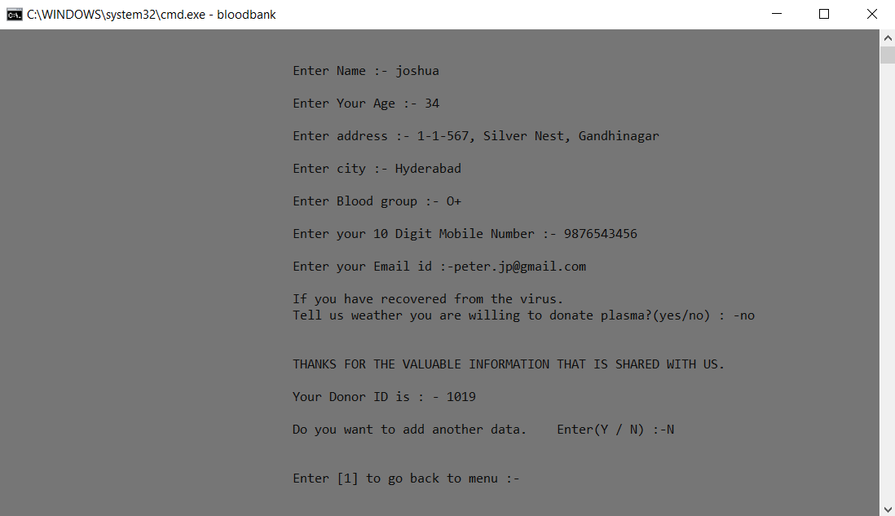

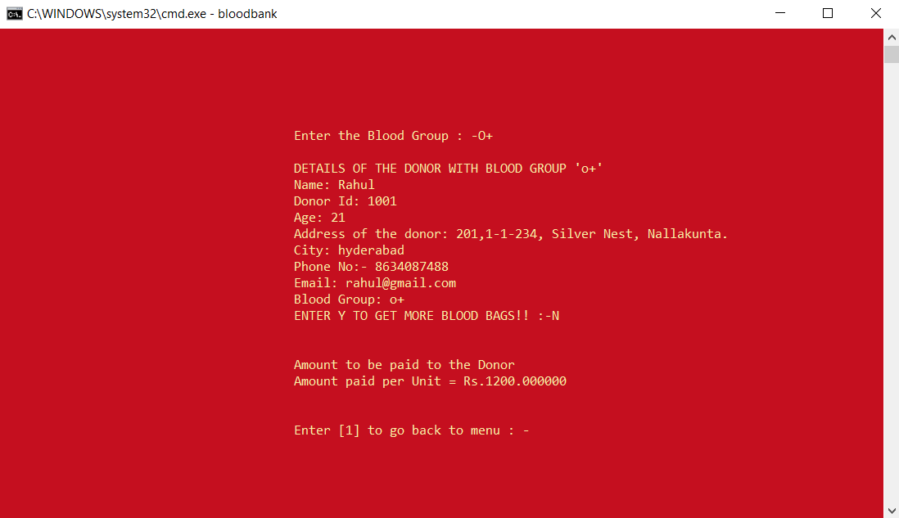

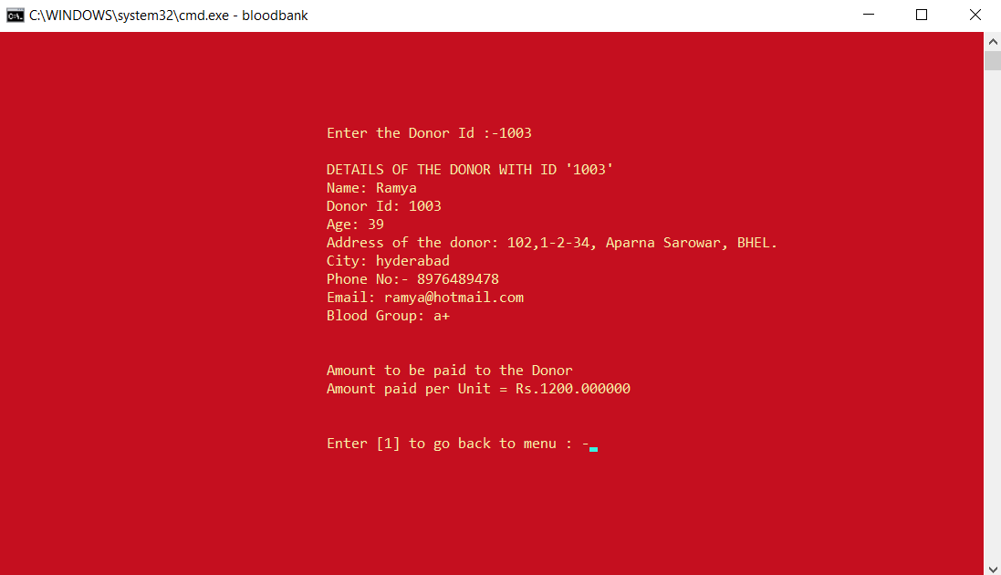

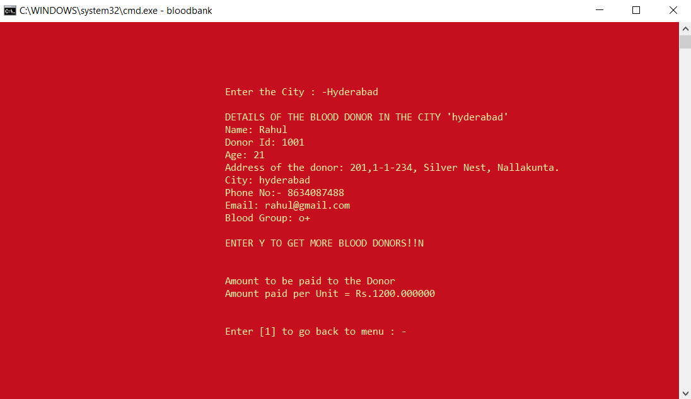

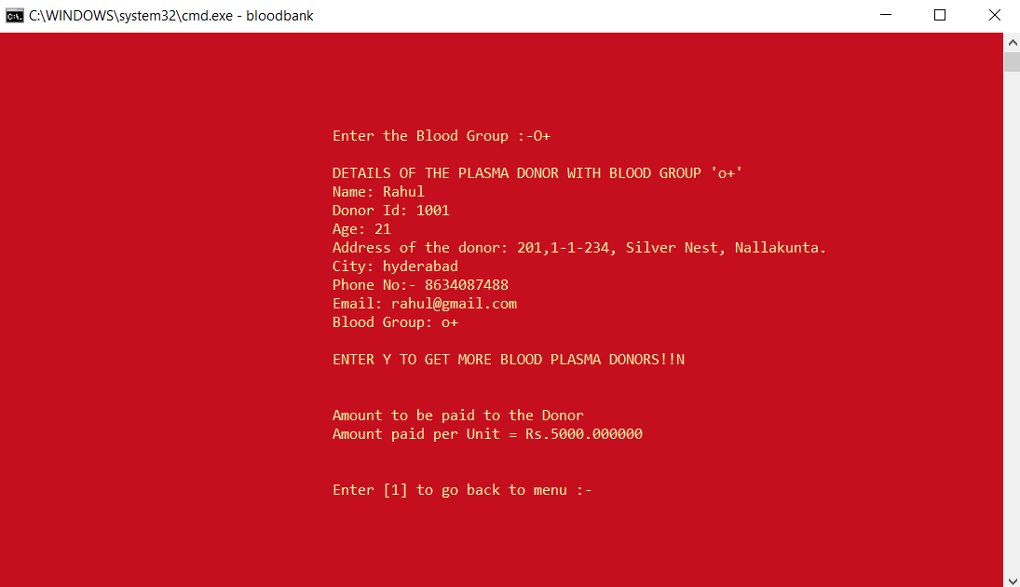

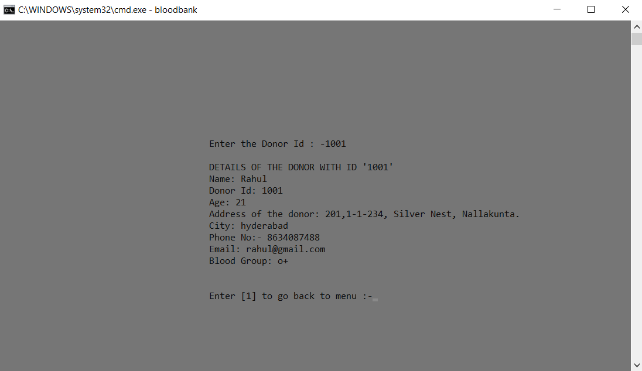

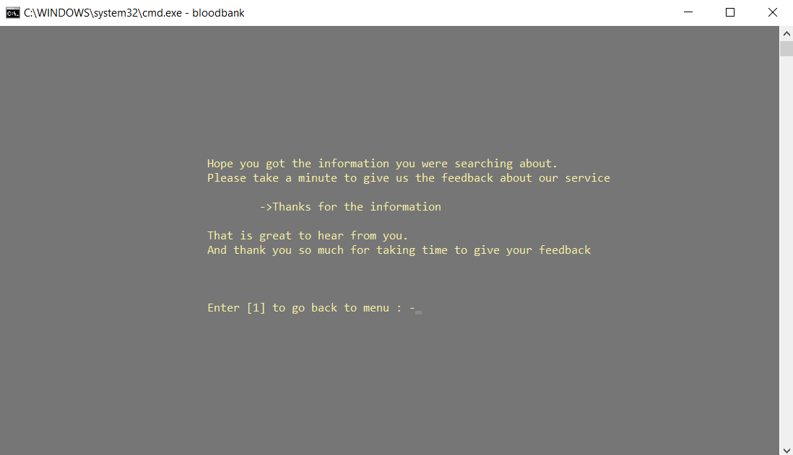

# **5. ADDITIONAL KNOWLEDGE ACQUIRED**

Implementing this project in C Language has introduced us to different libraries such as: ‘conio.h’, ‘Windows.h’. We explored the ‘Windows.h’ and ‘conio.h’ libraries for achieving a look-and-feel of an actual window application.

Also, we have further improved in our knowledge in file-handling because of the vast amount of data manipulation we have done using text files.

Other than this, we have learnt the value of team spirit and have understood the intention behind working in teams. We have learnt to be team players.

# **6. Discussion and Future Work**

To conclude, “BLOOD BANK MANAGEMENT SYSTEM” is a console-based C Project which acts as an application to search for the details of the blood donor or plasma donor. The intent behind this project is to provide the information of the donor to the people, who are in need. This application has even more scope now due to the pandemic situation. We need to create more such applications that will be useful for people to do all sorts of tasks from the comfort and safety of their homes.

Our future work includes incorporating more concepts such as Data Structures and DBMS for storing and retrieving the details of the donor. It would help to store the details of the donors in a particular order and retrieving of the data would be easy.

This project can be further improved by converting it into a Mobile Application using Flutter or React Native.

# **7. References**

1. Visual Studio Code
2. Stack Overflow (for debugging errors): <https://stackoverflow.com/>